**Looks at the company site:** <https://thecloudadvisory.com/>

As you see, the above site is missing a career page. So create a career page(html page with form) which will accept student information along with resume in text.

**Career Page:**

Full Name: text

Email ID: Email id

Phone Number: Number

Cover latter: text

Once studnet will submit the above information. It will call the AWS API Gateway that will accept the above information and it will call the lambda fucation. Lambda funcation will extract the student information from the form and insert data into Mysql Database.

Below is the architecture:

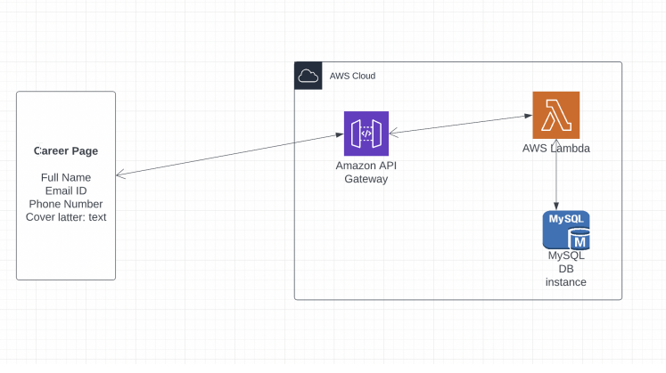

**Technology:** Feel free to use any programing language for Lambda function.

**How to submit the code**: Create a github project and put your code, instruction, README to run the code.

First create database table for storing information

1. aws>>dynamodb>>create table

Create policy so that lambda can access dynamodb create role for ir

Create lambda function with role created above.

Design appropriate handler function.

Now create api with post request enabling cors with post request and integrate with lambda

Create s3 bucket for storing and hosting page